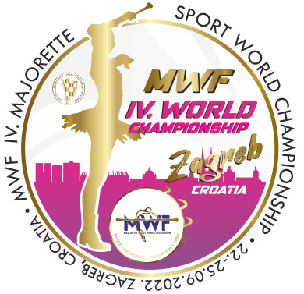
MWF/IV. MAJORETTE SPORT WORLD CHAMPIONSHIP
ZAGREB-CRO/22.-25.09.2022.
T-SHIRTS-Deadline 20.08.2022.
Send by e-mail :savez.mazoretkinja.hrvatske@gmail.com
TEAM:
Country:
Town:
Club:
Contact person:
Adress:
Mob:
E-mail:

T-SHIRTS /WHITE | NUMBER | CALCULATION | TOTAL EUR
KIDS-number  6,8,10,12,  PRICE- 8,00 EUR |  | Number x =
WOMEN-S, M, L, XL  PRICE- 9,00 EUR |  | Number x =
MEN/WHITE-S, M, L, XL, XXL  PRICE-10,00 EUR |  | Number x =
Total for T-SHIRTS
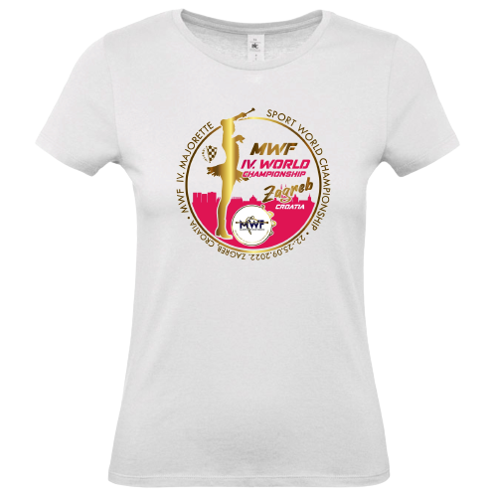
ON THE CHAMPIONSHIP DAYS- PRICE:

- KIDS-9,00 EUR
- WOMEN-WHITE /10,00 EUR
- MEN-11,00 EUR

