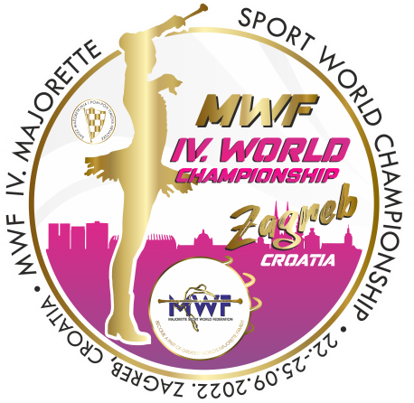
MWF/IV.MAJORETTE SPORT WORLD CHAMPIONSHIP
ZAGREB-CRO/22.-25.09.2022.
APPLICATION FORM
FOOD
DEADLINE-20.08.2022.
DATE: | LUNCH/ 6.00 eur | DINNER/ 6.00 eur
23.09.2022. | A/PASTA BOLOGNESE | A/RISOTTO WITH PORK AND VEGETABLES /gluten-free/
 | B/GRILL CHICKEN FILLET + COLORFUL RICE /gluten-free/ | B/BREADED CHICKEN FILLET + GRIED POTATOES
24.09.2022. | A/PORK ROAST WITH POTATOES /gluten-free/ | A/WOK WITH CHICKEN /gluten-free/
 | B/CHICKEN PEPPER + PASTA | B/PORK STEAK WITH VEGETABLES + BOILED POTATOES
25.09.2022. | A/RISOTTO WITH CHICKEN /gluten-free/ | A/PORK PEPPER + PALENTA
 | B/PORK STEAK IN MEDITERRANEAN HERB SAUCE + PASTA | B/MARINATED AND BAKED CHICKEN WITH BIZI RICE /gluten-free/
Food are served in a tent next to the sport hall where is a reserved space for all users who have ordered meals.
RESERVATION:
DEADLINE-20.08.2022.
E-mail: savez.mazoretkinja.hrvatske@gmail.com
Payment of 30% to 20.08.2022./ALL -15.09.2012.
Adress: SAVEZ MAŽORETKINJA I POM-PON TIMOVA HRVATSKE
Frana Vrbanića 58. 10 000 ZAGREB
Bank account: RBA Raifeissen bank Austria d.d.
IBAN HR922 484 0081 101 900 360 SWIFT: RZBHHR2X

TEAM:

CONTACT PERSON:

E-mail:

Mob:

Data for invoice:

DATE | LUNCH-A/ B | DINNER-A/B | TOTAL
23.09.2022.

24.09.2022.

25.09.2022.

ALL:

Date:_____________________ Signature:______________
