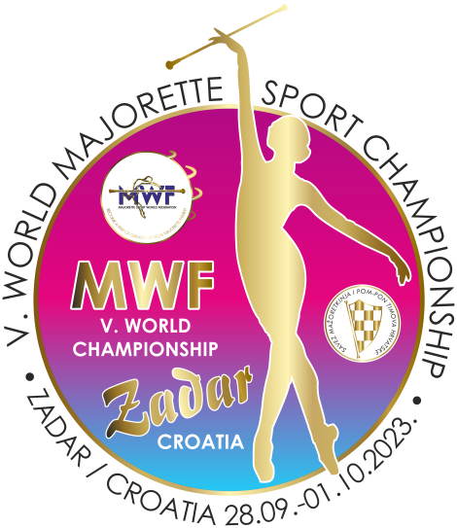
MWF/V.WORLD MAJORETTE SPORT CHAMPIONSHIP
ZADAR-CRO/28.09.-01.10.2023.
APPLICATION FORM
FOOD
DEADLINE-01.09.2023.
DATE: | LUNCH/ 8.00 eur  70% /for kids / 6.50 eur | DINNER/ 8.00 eur  70% /for kids / 6.50 eur
29.09.2023. | A/PASTA BOLOGNESE | A/RISOTTO WITH PORK AND VEGETABLES /gluten-free/
 | B/GRILL CHICKEN FILLET + COLORFUL RICE /gluten-free/ | B/BREADED CHICKEN FILLET + GRIED POTATOES
30.09.2023. | A/PORK ROAST WITH POTATOES /gluten-free/ | A/WOK WITH CHICKEN /gluten-free/
 | B/CHICKEN PEPPER + PASTA | B/PORK STEAK WITH VEGETABLES + BOILED POTATOES
01.10.2023. | A/RISOTTO WITH CHICKEN /gluten-free/ | A/PORK PEPPER + PALENTA
 | B/PORK STEAK IN MEDITERRANEAN HERB SAUCE + PASTA | B/MARINATED AND BAKED CHICKEN WITH BIZI RICE /gluten-free/

E-mail: savez.mazoretkinja.hrvatske@gmail.com
Payment of 30% to 01.09.2023./ALL -20.09.2023.
Adress: SAVEZ MAŽORETKINJA I POM-PON TIMOVA HRVATSKE
Frana Vrbanića 58. 10 000 ZAGREB
Bank account: RBA Raifeissen bank Austria d.d.
IBAN HR922 484 0081 101 900 360 SWIFT: RZBHHR2X

TEAM:

CONTACT PERSON:

E-mail:

Mob:

Data for invoice:

DATE | LUNCH-A/ B | DINNER-A/B | TOTAL
28.09.2023.
29.09.2023.
30.09.2023.
01.10.2023.
ALL:

Date:_____________________ Signature:______________
