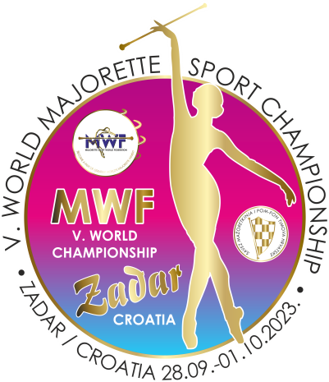
MWF/V. WORLD MAJORETTE SPORT CHAMPIONSHIP
ZADAR-CROATIA/28.09.-01.10.2023.
T-SHIRTS-Deadline 01.09.2023.
Send by e-mail :savez.mazoretkinja.hrvatske@gmail.com
TEAM:
Country:
Town:
Club:
Contact person:
Adress:
Mob:
E-mail:

T-SHIRTS /WHITE-BLACK | NUMBER | CALCULATION | TOTAL EUR
KIDS-number  6,8,10,12,  WHITE/ 9,00 EUR  BLACK/10.00 EUR |  | Number x =
WOMEN-S, M, L, XL  WHITE/ 10,00 EUR  BLACK/11.00 EUR |  | Number x =
MEN/-S, M, L, XL, XXL  WHITE/ 10,00 EUR  BLACK/11.00 EUR |  | Number x =
TOTAL:

ON THE CHAMPIONSHIP DAYS:
- KIDS/WHITE-10,00 EUR/BLACK-11.00 EUR
- WOMEN/ WHITE-12,00 EUR/BLACK-13.00 EUR
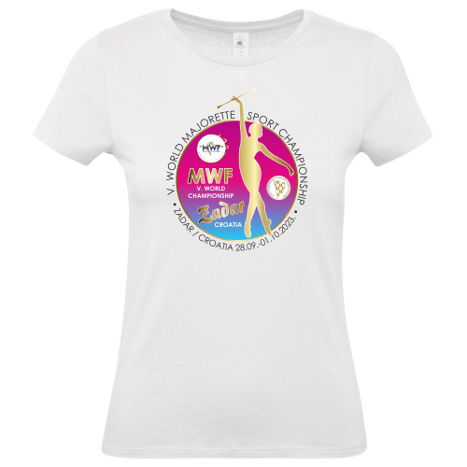
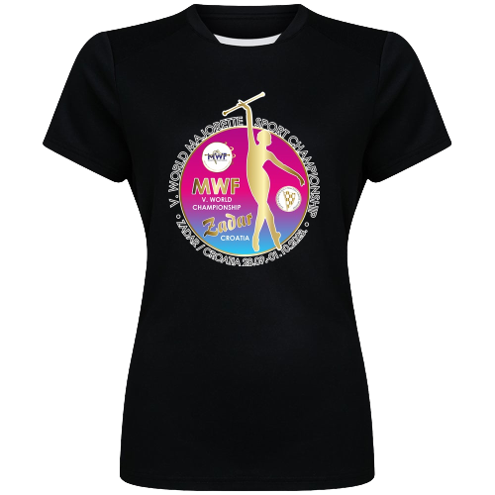
- MEN/ WHITE-12,00 EUR/BLACK-13.00 EUR

