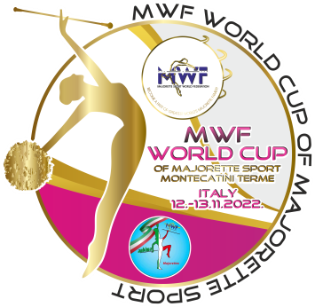
MWF/WORLD CUP of MAJORETTE SPORT
MONTECATINI TERME-IT/12.-13.11.2022.
T-SHIRTS-Deadline 30.10.2022.
Send by e-mail :mwf.championship@gmail.com
TEAM:
Country:
Town:
Club:
Contact person:
Adress:
Mob:
E-mail:

T-SHIRTS /WHITE-BLACK | NUMBER | CALCULATION | TOTAL EUR
KIDS-number  6,8,10,12,  WHITE/ 9,00 EUR  BLACK/10.00 EUR |  | Number x =
WOMEN-S, M, L, XL  WHITE/ 10,00 EUR  BLACK/11.00 EUR |  | Number x =
MEN/-S, M, L, XL, XXL  WHITE/ 10,00 EUR  BLACK/11.00 EUR |  | Number x =
TOTAL:

ON THE CHAMPIONSHIP DAYS:
- KIDS/WHITE-10,00 EUR/BLACK-11.00 EUR
- WOMEN/ WHITE-11,00 EUR/BLACK-12.00 EUR
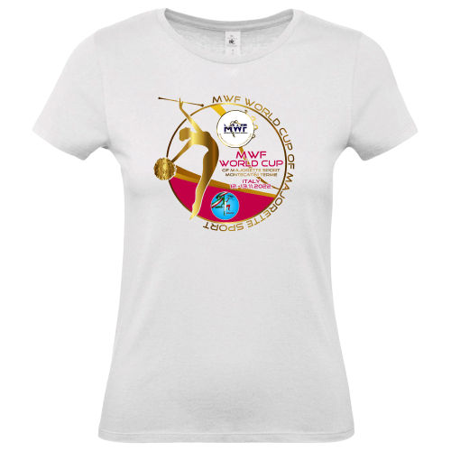
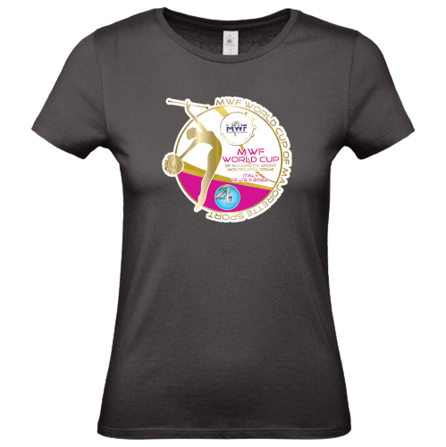
- MEN/ WHITE-11,00 EUR/BLACK-12.00 EUR

