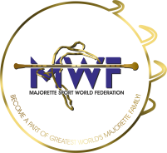
MWF-XVIi. EUROPEAN MAJORETTE SPORT CHAMPIONSHIP
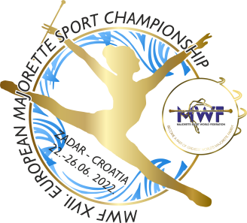
ZADAR/CROATIA.22.-26.06.2022.
T-SHIRTS-Deadline 01.06.2022.
Send by e-mail :savez.mazoretkinja.hrvatske@gmail.com
TEAM:
Country:
Town:
Club:
Contact person:
Adress:
Mob:
E-mail:

T-SHIRTS | NUMBER | CALCULATION | TOTAL EUR
KIDS-number  6,8,10,12,  PRICE- 8,00 EUR |  | Number x =
WOMEN-S, M, L, XL A) WHITE-  PRICE- 9,00 EUR  B) PINK-  PRICE 10.00 EUR |  | Number x =
MEN/WHITE-S, M, L, XL, XXL  PRICE-10,00 EUR |  | Number x =
Total for T-SHIRTS

ON THE CHAMPIONSHIP DAYS- PRICE: -KIDS-9,00 EUR
-WOMEN-WHITE /10,00 EUR PINK/11.00 EUR
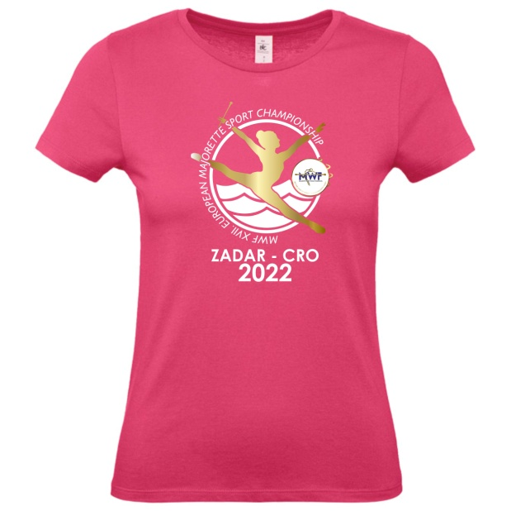
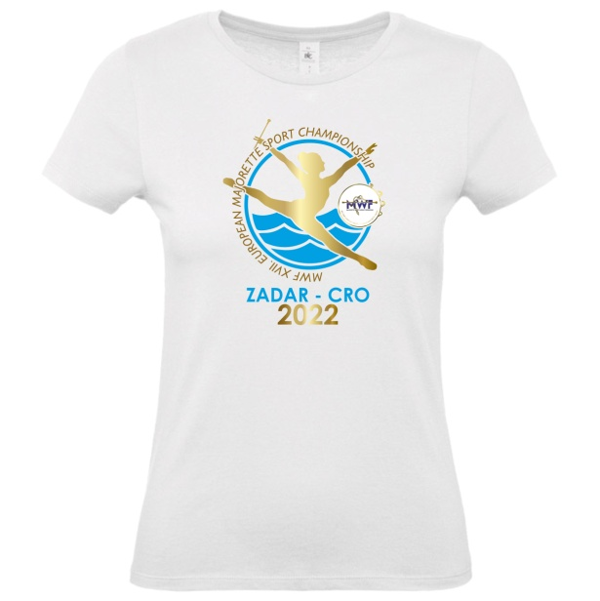
-MEN-11,00 EUR

