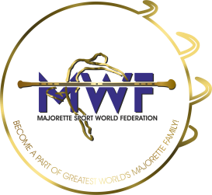
MWF-IV. MAJORETTE SPORT WORLD CHAMPIONSHIP
ZAGREB-CROATIA , 22.-25.09.2022.

BASIC REGISTRATION FORM

Deadline 15.08.2022.

E-MAIL:

mwf.majorettes1@gmail.com
judicalcommitee.mwf1@gmail.com

COUNTRY:
TOWN:
TEAM:
CONTACT PERSON:
E-MAIL:
MOB:
DATA FOR INVOICE:

COMPETITOR FEE -each competitor- 6,00 EUR for each category

REGISTRATION FEE for each category :
SOLO-10,00 EUR
DUO-TRIO-15,00 EUR
MINI FORMATIONS-25,00 EUR
GROUPS-30,00 EUR
___________________________________________________________________________
ALL PAYMENT AT:
Account: MAJORETTE SPORT WORLD FEDERATION
Adress: ERSTE&STEIERMÄRKISCHE BANK D.D./JADRANSKI TRG 3a, 51000 RIJEKA
IBAN: HR4324020061100809283 / SWIFT: ESBCHR22

DEADLINE/ 20.08.2022.

GROUPS / Registration fee € 30 for every team
BAT  POM  MIX  BATONFLAG  CLASSIC  DEFILE  MACE  DRUMMERS  SMALL DRILL | CAD  JUN  SEN | Teams name | Number person | Reg.fee  30 EUR  for team
 |  |  | 6,00 X
SUM person and registration fee per groups

SOLO FORMATION Reg.fee solo € 10, duo-trio € 15, mini € 25
BAT  POM  MIX  FLAG  ACROBATIC  MACE  DRUMMERS | CAD  JUN  SEN | solo  duo  trio  mini | Name majorettes and birth year for solo or duo-trio | Num  ber  person | Reg.fee
 |  |  |  | 6,00 X
SUM person and registration fee per solo formation
TOTAL per solo formation + groups

