MWF-V. WORLD MAJORETTE SPORT CHAMPIONSHIP
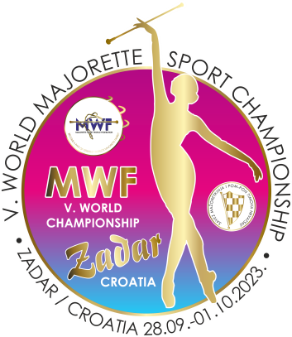
ZADAR-CRO/28.09.-01.10.2023.
ACCOMODATION
APPLICATION FORM
DEADLINE 01.09.2023.
E-mail: accomodation.mwf@gmail.com
-payment of 30% to with reservation/ALL 20.09.2023.
Adress: SAVEZ MAŽORETKINJA I POM-PON TIMOVA HRVATSKE
Bank account: RBA Raifeissen bank Austria d.d.
IBAN HR922 484 0081 101 900 360
SWIFT: RZBHHR2X
TEAM:
CONTACT PERSON:
E-MAIL:
MOB:

DATE: | Place for accomodation-  number: /1,2,3.../hostel, APP/ | NUMBER PERSON FOR ACCOMODATION  /price per person/ | TOTAL:
27.-28.09.2023.
28-29..09.2023.
29.-30.09.2023.
30.09.-01.10.2023.
01.-02.10.2023.
ALL:

Date:_____________ ______________________
Signature:

