MWF-IV. MAJORETTE SPORT WORLD CHAMPIONSHIP
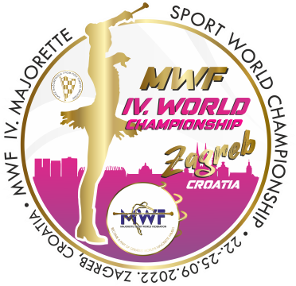
ZAGREB-CRO/22.-25.09.2022.
ACCOMODATION
APPLICATION FORM
DEADLINE 20.08.2022.
E-mail: accomodation.mwf@gmail.com
-payment of 30% to with reservation/ALL 15.09.2022.
Adress: SAVEZ MAŽORETKINJA I POM-PON TIMOVA HRVATSKE
Bank account: RBA Raifeissen bank Austria d.d.
IBAN HR922 484 0081 101 900 360
SWIFT: RZBHHR2X
TEAM:
CONTACT PERSON:
E-MAIL:
MOB:

DATE: | Place for accomodation-  number: /1,2,3.../hostel, hotel/ | NUMBER PERSON FOR ACCOMODATION  /price per person/ | TOTAL:
21.-22.09.2022.
22-23..09.2022.
23.-24.09.2022.
24.-25.09.2022.
25.-26.09.2022.
ALL:

Date:_____________ ______________________
Signature:

