MWF-XVIII. EUROPEAN MAJORETTE SPORT CHAMPIONSHIP
COUNTRY:
TOWN:
TEAM:
NUMBER of COMPETITORS:
CADETS /number/:
JUNIORS /number/:
SENIORS/number/:
CONTACT PERSON:
M0B:
E-MAIL:
MARIBOR-SLO/22.-25.06.2023.
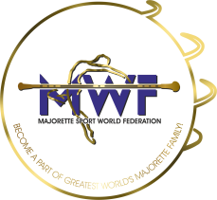
LIST OF COMPETITORS

Deadline:18.05.2023.

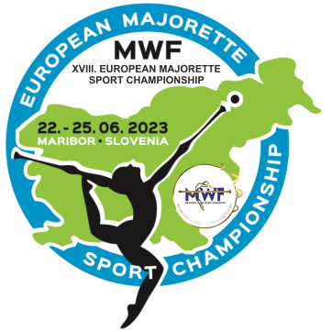
E-mail :

mwf.majorettes1@gmail.com

judicalcommitee.mwf1@gmail.com

 | CADETS/JUNIORS/  SENIORS | FULL NAME OF COMPETITORS | DATE OF BIRTH:
1.
2.
3.
4.
5.
6.
7.
8.
9.
10.
11.
12.
13.
14.
15.
16.
17.
18.
19.
20.
21.
22.
23.
24.
25.
26.
27.
28.
29.
30.
31.
32.

NAME AND DATE OF BIRTH/EVERY CATEGORY:

CATEGORY: /SOLO BATON../etc | NAME: | DATE OF BIRTH:

Date:________________________ ___________ Signature:____________________________________

