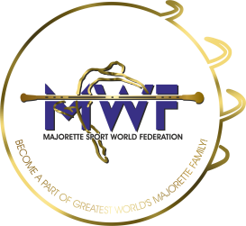
MWF-XVIII.EUROPEAN MAJORETTE SPORT CHAMPIONSHIP
MARIBOR-SLO/22.-25.06.2023.

BASIC REGISTRATION FORM

Deadline 18.05.2023.

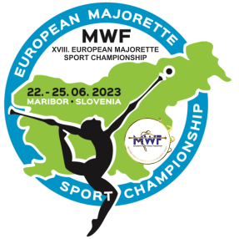
SEND TO E-MAIL:

mwf.majorettes1@gmail.com

judicalcommitee.mwf1@gmail.com
COUNTRY:
TOWN:
TEAM:
CONTACT PERSON:
E-MAIL:
MOB:
DATA FOR INVOICE:

COMPETITOR FEE:-DEADLINE-20.05.2023.
–SOLO-/15.00 EUR
-DUO-TRIO /10.00 EUR / every competitor/
-MINI FORMATION/10.00 EUR / every competitor/
-GROUP/10.00 EUR / every competitor/

REGISTRATION FEE for each category :-DEADLINE-01.06.2023.
-SOLO/15,00 EUR
-DUO-TRIO/25,00 EUR
-MINI FORMATIONS/35,00 EUR
-GROUPS/45,00 EUR
Payment at
Account: MAJORETTE SPORT WORLD FEDERATION
Adress: ERSTE&STEIERMÄRKISCHE BANK D.D./JADRANSKI TRG 3a, 51000 RIJEKA
IBAN: HR4324020061100809283 / SWIFT: ESBCHR22

GROUPS / Registration fee € 45.00 for every team
BAT  POM  MIX  BATONFLAG  CLASSIC BAT.  CLASSIC POM  DEFILE BAT.  DEFILE POM  MACE  DRUMMERS  SMALL DRILL | CAD  JUN  SEN | Teams name | Number person | Reg.fee  45.00 EUR  for team
 |  |  | X
SUM person and registration fee per groups

SOLO FORMATION Reg.fee solo € 15 /duo-trio € 25 /mini € 35
BAT  POM  MIX  BATONFLAG  MACE  TWIRLING  DRUMMERSDRUMMERS | CAD  JUN  SEN | solo  duo  trio  mini | Name majorettes and birth year for solo or duo-trio | Number  person | Reg.fee
 |  |  |  | X
SUM person and registration fee per solo formation
TOTAL per solo formation + groups

