MWF-XVII. EUROPEAN MAJORETTE SPORT CHAMPIONSHIP
ZADAR/CROATIA
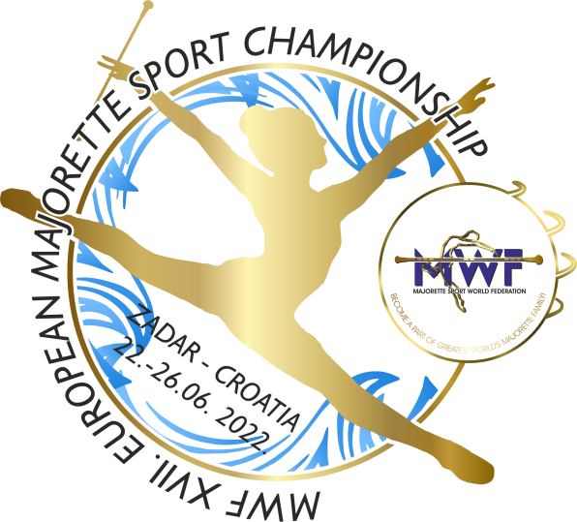
22.-26.06.2022.
ACCOMODATION
APPLICATION FORM
DEADLINE 01.06.2022.
E-mail: accomodation.mwf@gmail.com
-payment of 30% to with reservation/ALL 05.06.2022.
Adress: SAVEZ MAŽORETKINJA I POM-PON TIMOVA HRVATSKE
Bank account: RBA Raifeissen bank Austria d.d.
IBAN HR922 484 0081 101 900 360
SWIFT: RZBHHR2X
ACCOMODATION:
DATE: | Place for accomodation-  number: /1,2,3.../hostel, hotel,villa, village... | NUMBER PERSON FOR ACCOMODATION  /price per person/ | TOTAL:
21.-22.06.2022.
22-23..06.2022.
23.-24.06.2022.
24.-25.06.2022.
25.-26.06.2022.
26.-27.06.2022.
ALL:

Date:_____________ ______________________
Signature:

