MWF-XIX.EUROPEAN MAJORETTE SPORT CHAMPIONSHIP
LIBEREC-CZ/04.07. -07.07.2024

BASIC REGISTRATION FORM

Deadline 25.05.2024.

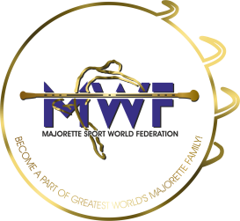
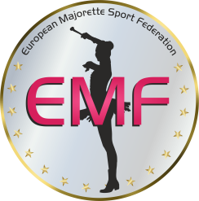
SEND TO E-MAIL:

mwf.majorettes1@gmail.com

judicalcommitee.mwf1@gmail.com
COUNTRY:
TOWN:
TEAM:
CONTACT PERSON:
E-MAIL:
MOB:
DATA FOR INVOICE:

COMPETITOR FEE:-DEADLINE- 01.06.2024.
–SOLO-/15.00 EUR
-DUO-TRIO /10.00 EUR / every competitor/
-MINI FORMATION/10.00 EUR / every competitor/
-GROUP/10.00 EUR / every competitor/
Payment on Account CZECH MAJORETTE ASSOCIATION:
FIO BANKA
IBAN: CZ74 2010 0000 0029 0277 7301
BIC/SWIFT: FIOBCZPPXXX

REGISTRATION FEE for each category :-DEADLINE-10.06.2024.
-SOLO/15,00 EUR
-DUO-TRIO/25,00 EUR
-MINI FORMATIONS/35,00 EUR
-GROUPS/45,00 EUR
Payment at Account: MAJORETTE SPORT WORLD FEDERATION
Adress:ERSTE&STEIERMÄRKISCHE BANK D.D./JADRANSKI TRG 3a, 51000 RIJEKA
IBAN: HR4324020061100809283 / SWIFT: ESBCHR22
GROUPS/ Registration fee€ 45.00 for every team
BAT  POM  MIX  FLAG  MACE  CLASSIC BAT.  CLASSIC POM  DEFILE BAT.  DEFILE POM  DEFILE CLASSIC BATON  DRUMMERS | CAD  JUN  SEN | Teams name | Number person  x competitor fee | Reg.fee  45.00 EUR  for team
Example: POM | CAD | VIROVITIČKE MAŽORETKINJE | 16X10 | 45€
SUM person and registration fee per groups
TOTAL AMOUNT

SOLO FORMATIONReg.fee solo € 15 /duo-trio € 25 /mini € 35
BAT  POM  MIX  FLAG  MACE  TWIRLING/Acrobat.  DRUMMERS  DRUMMERS | CAD  JUN  SEN | solo  duo  trio  mini | Name majorettesand birth year for solo or duo-trio | Number  person | Reg.fee
Example: BAT | CAD | TRIO | EMA MALECKA, JANa TOTH, ELENA KORMOŠ, | 3X10 | 55€
SUM person and registration fee per solo formation
TOTAL AMOUNT

TOTAL per solo formation + groups

