MWF-XIX. EUROPEAN MAJORETTE SPORT CHAMPIONSHIP
COUNTRY:
TOWN:
TEAM:
NUMBER of COMPETITORS:
CADETS /number/:
JUNIORS /number/:
SENIORS/number/:
CONTACT PERSON:
M0B:
E-MAIL:
LIBEREC-CZ/04.07. – 07.07.2024.
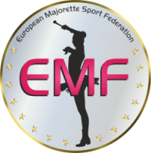
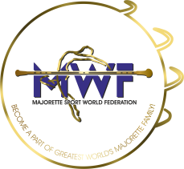
LIST OF COMPETITORS

Deadline:25.05.2024.

E-mail :

mwf.majorettes1@gmail.com

judicalcommitee.mwf1@gmail.com

NUMBER | CADETS/JUNIORS/  SENIORS | FULL NAME OF COMPETITORS | DATE OF BIRTH:
Example 1. | CADETS | SARA TOTH | 2.1.2014.

NAME AND DATE OF BIRTH/EVERY CATEGORY:

CATEGORY: /SOLO BATON../etc | NAME: | DATE OF BIRTH:
Example:  BAT/CAD/TRIO | EMA MALECKA  JANA KIM  ELENA TOTH | 5.2.2014  7.6.2013.  1.8.2013.

Date:___________________________ Signature:

__________________________
__________________________

President and coach:

