MWF-XVII. EUROPEAN MAJORETTE SPORT CHAMPIONSHIP
ZADAR/CROATIA,22.-26.06.2022.
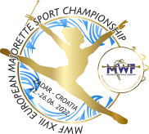
APPLICATION FORM

FOOD
DATE: | LUNCH/ 8,00 eur | DINNER/ 8.00 eur
22.06.2022. | A/ Chicken Cordon bleu with rice and vegetables /bread | A/chicken nuggets in mushroom sauche with rice/bread
 | B/ Filled pork with vegetables and baked potato/bread | B/Pork Cordon blue with n+baked potato/bread
23.06.2022. | A/ Chichen stew with pasta/bread | A/ Pork chops with baked potato/bread
 | B/ Chichen on sticks and pommes/bread | B/Pasta Bolognese sauce/bread
24.06.2022. | A/ Wok chichen with rice/bread | A/Chicken on sticks with vegetables and pommes/bread
 | B/Gnocchi in 4 types of cheese sauce/bread | B/Chicken Stroganoff with wide noodles/bread
25.06.2022. | A/Chicken leg with homemade „mlinci“/bread | A/Meatballs with mashed potato/bread
 | B/Homemade pasta with vegetables/bread | B/Viennese pork steak with mashed potato/bread
26.06.2022. | A/Pasta Napolitana sauce/bread | A/pork roast with roasted vegetables/bread
 | B/cevapcici with pommes/bread | B/Lasagna meat/bread
Food are served in a tent next to the sport hall where is a reserved space for all users who have ordered meals.
RESERVATION:
DEADLINE-01.06.2022.
E-mail: accomodation.mwf@gmail.com
Payment of 30% to 01.06.2022./ALL -15.06.2019.
Adress: SAVEZ MAŽORETKINJA I POM-PON TIMOVA HRVATSKE
Frana Vrbanića 58. 10 000 ZAGREB
Bank account: RBA Raifeissen bank Austria d.d.
IBAN HR922 484 0081 101 900 360 SWIFT: RZBHHR2X

DATE | LUNCH-A/ B | DINNER-A/B | TOTAL
22.06.2022.
23.06.2022.
24.06.2022.
25.06.2022.
26.06.2022.
ALL:

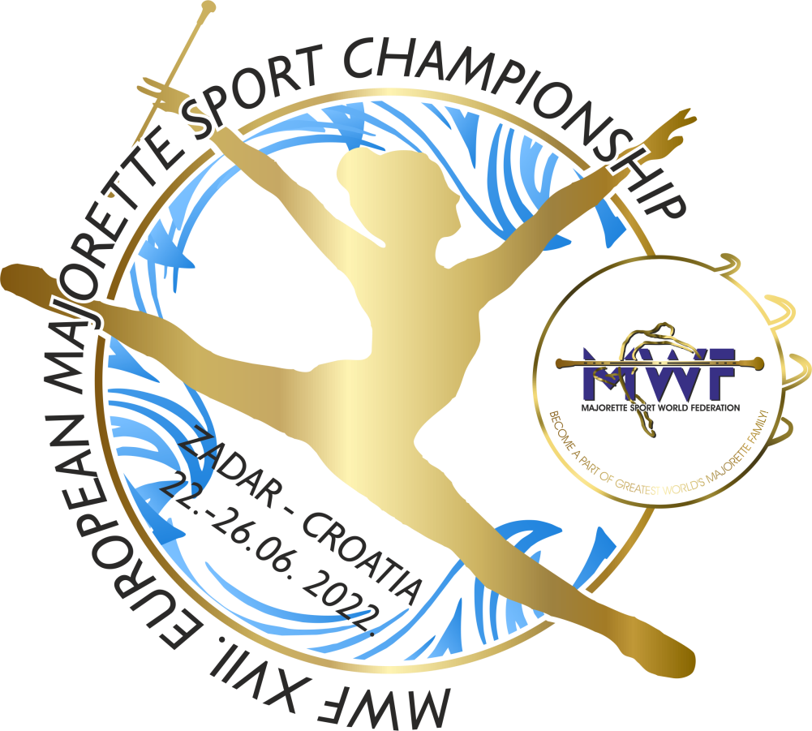
Date:_____________________ Signature:______________

