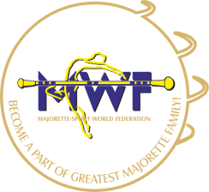
MWF-XVI. EUROPEAN MAJORETTE SPORT CHAMPIONSHIP
ZAGREB/CRO,04.-07.07.2019.

BASIC REGISTRATION FORM

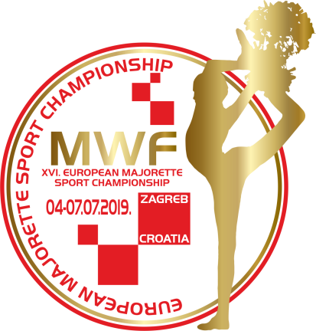
Deadline 20.05.2019.

E-MAIL:

majorettes.mwf@gmail.com
judicalcommitee.mwf1@gmail.com

COMPETITOR FEE -each competitor- 5,00 EUR for each category
Payment at
SAVEZ MAŽORETKINJA I POM-PON TIMOVA HRVATSKE
RBA-Raiffeisen bank Austria d.d
IBAN HR922 484 008 1101 900 360
SWIFT: RZBHHR2X

REGISTRATION FEE for each category :
SOLO-10,00 EUR
DUO-TRIO-15,00 EUR
MINI FORMATIONS-25,00 EUR
GROUPS-30,00 EUR
Payment at
Account: MAJORETTE SPORT WORLD FEDERATION
Adress: ERSTE&STEIERMÄRKISCHE BANK D.D./JADRANSKI TRG 3a, 51000 RIJEKA
IBAN: HR4324020061100809283
SWIFT: ESBCHR22

Country Town Club
Contact person name | Mob: |  | E-mail
Adress: |  | Data for invoice:

GROUPS / Registration fee € 30 for every team
BAT /POM/ FLAG  MIX/MACE/CLASSIC  DRUMMERS/DEFILE  SMALL DRILL | CAD  JUN  SEN | Teams name | Number person | Reg.fee  30 EUR  for team
 |  |  | 5,00 X
SUM person and registration fee per GROUPS

SOLO FORMATION Reg.fee SOLO € 10/ DUO-TRIO € 15/ MINI FORMATIIONS € 25
BAT  POM  MIX  FLAG  TWIRLING  MACE  DRUMMERS | CAD  JUN  SEN | solo  duo  trio  mini | Name majorettes and birth year for solo or duo-trio | Num  ber  person | Reg.fee
 |  |  |  | 5,00 X
SUM person and registration fee per SOLO FORMATIONS
TOTAL - solo formations + groups

