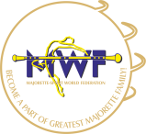
MWF-XVI. EUROPEAN MAJORETTE SPORT CHAMPIONSHIP
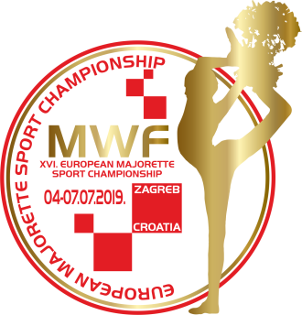
ZAGREB/CROTIA, 04.-07.07.2019.
APPLICATION FORM
FOOD
DEADLINE 01.06.2019.
E-mail: savez.mazoretkinja.hrvatske@gmail.com
Payment of 30% to 01.06.2019./ALL -20.06.2019.
Adress: SAVEZ MAŽORETKINJA I POM-PON TIMOVA HRVATSKE
Bank account: RBA Raifeissen bank Austria d.d.
IBAN HR922 484 0081 101 900 360 SWIFT: RZBHHR2X
DATE: | LUNCH/ 6,00 eur | DINNER/ 5,00 eur
04.07.2019. | A/ Chicken Cordon bleu with rice and vegetables | A/chicken nuggets in mushroom sauche with rice
 | B/ Filled pork with vegetables and baked potato | B/Pork Cordon blue with n+baked potato
05.07.2019. | A/ Chichen stew with pasta | A/ Pork chops with baked potato
 | B/ Chichen on sticks and pommes | B/Pasta Carbonara
06.07.2019. | A/ Wok chichen with rice | A/Chicken on sticks with vegetables and pommes
 | B/Gnocchi in 4 types of cheese sauce | B/Chicken Stroganoff with wide noodles
07.07.2019. | A/Chicken leg with homemade „mlinci“ | A/Meatballs with mashed potato
RESERVATION: | B/Homemade pasta with vegetables | B/Cryano steak with homemade gnocchi in gongorzola sauce

DATE | LUNCH-A/ B | DINNER-A/B | TOTAL
04.07.2019.
05.07.2019.
06.07.2019.
07.07.2019.
ALL:
Date:_____________________ Signature:______________________

